Panji Iman Baskoro

171111023

Praktikum Pemprograman Dasar 2

QUIZ

LinkedListNode.java

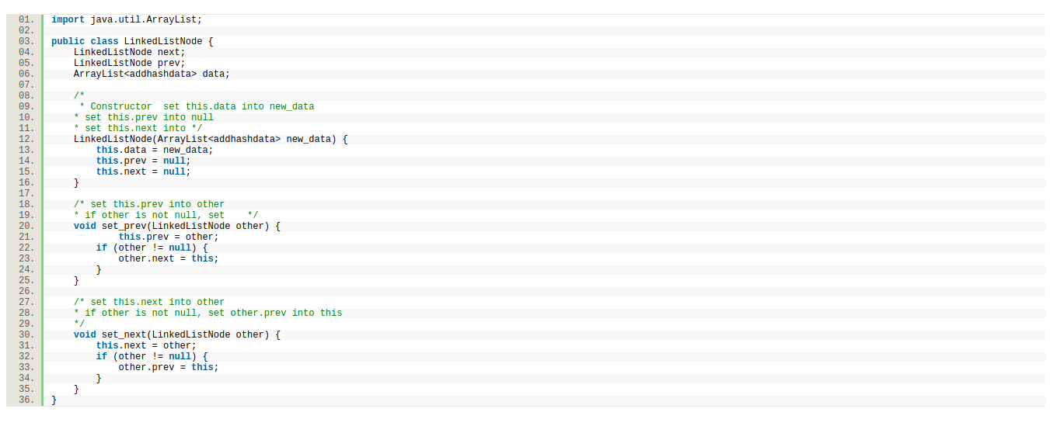

queueue.java

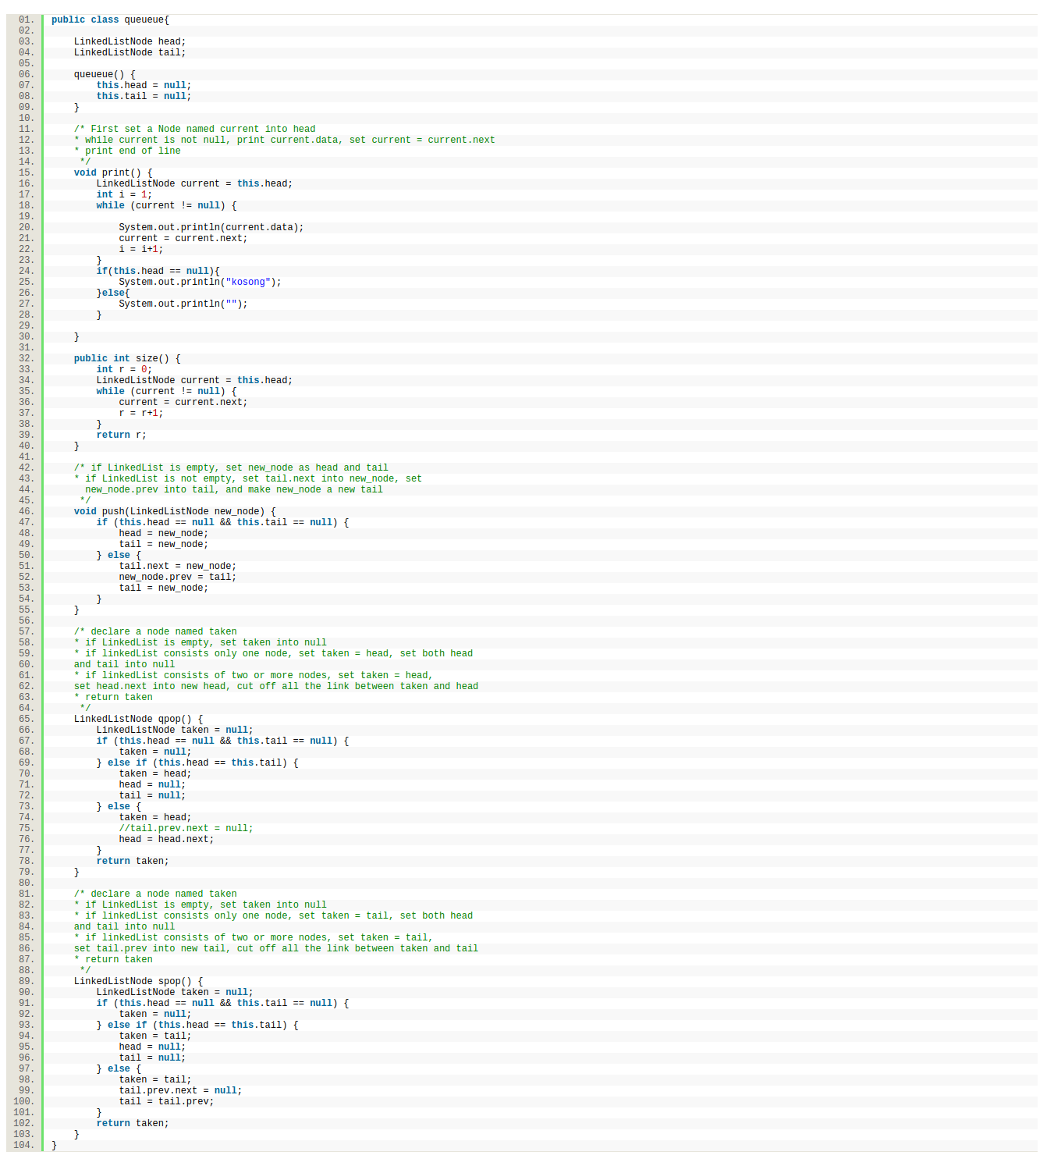

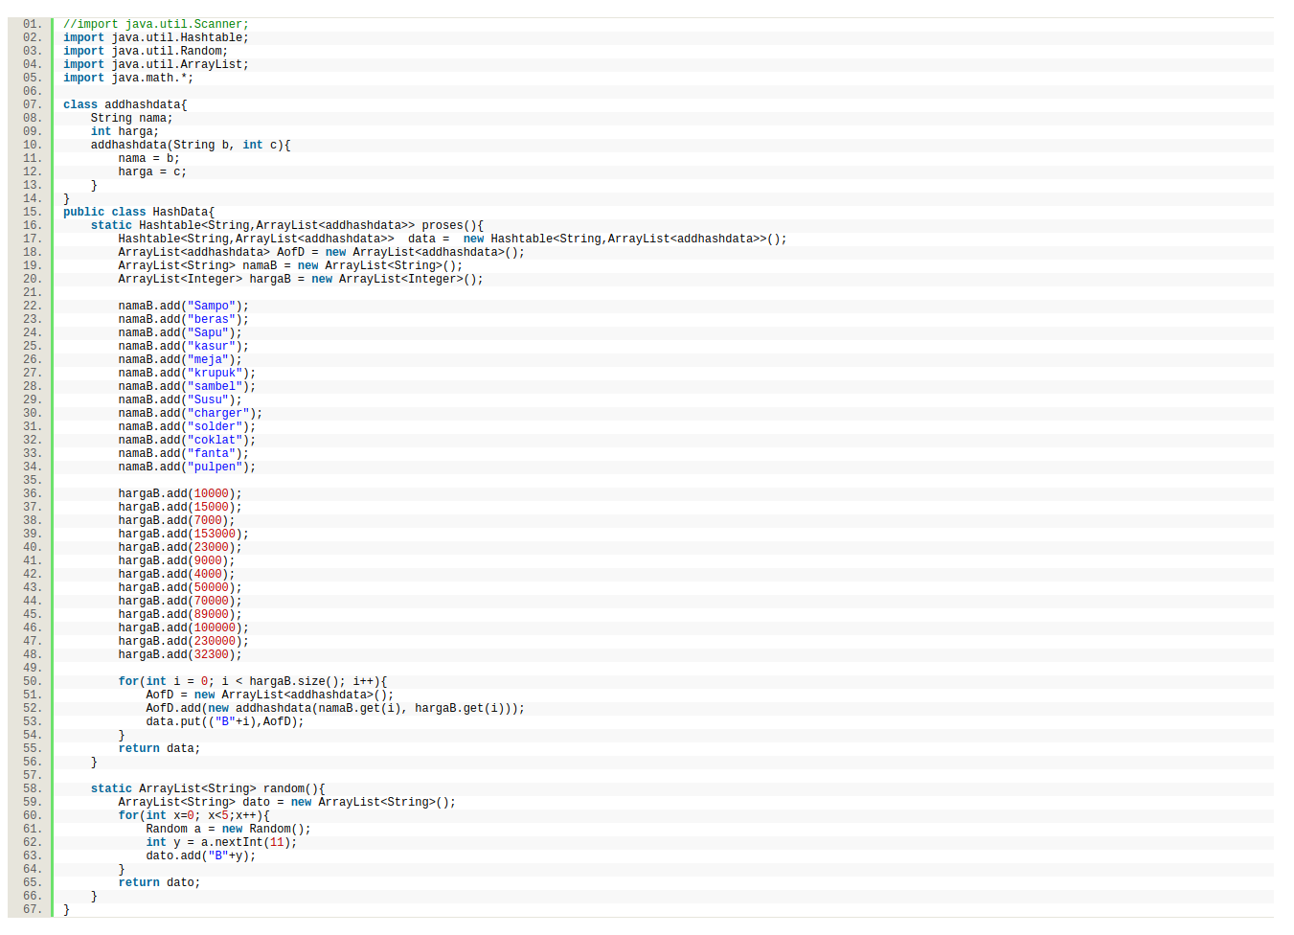HashData.java

addQ.java

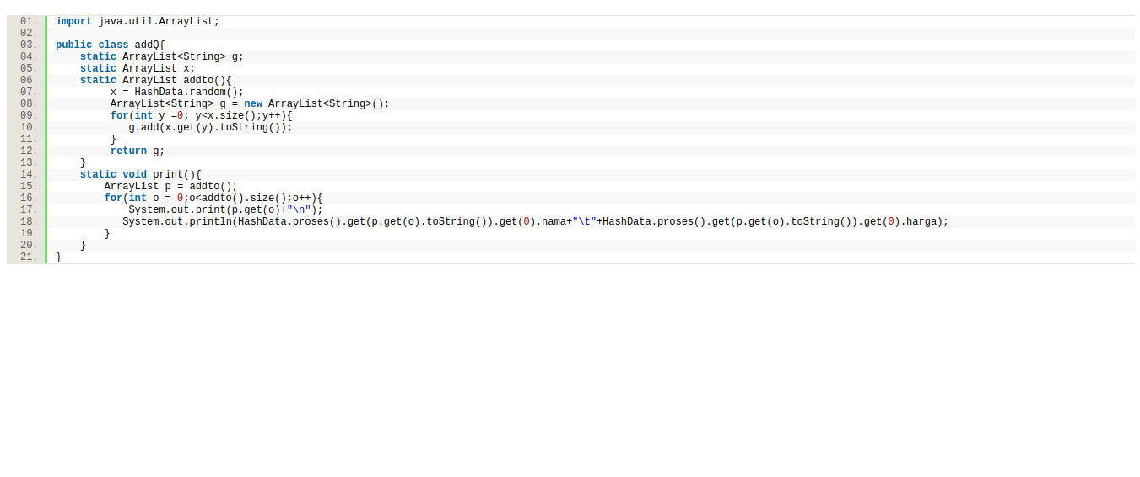

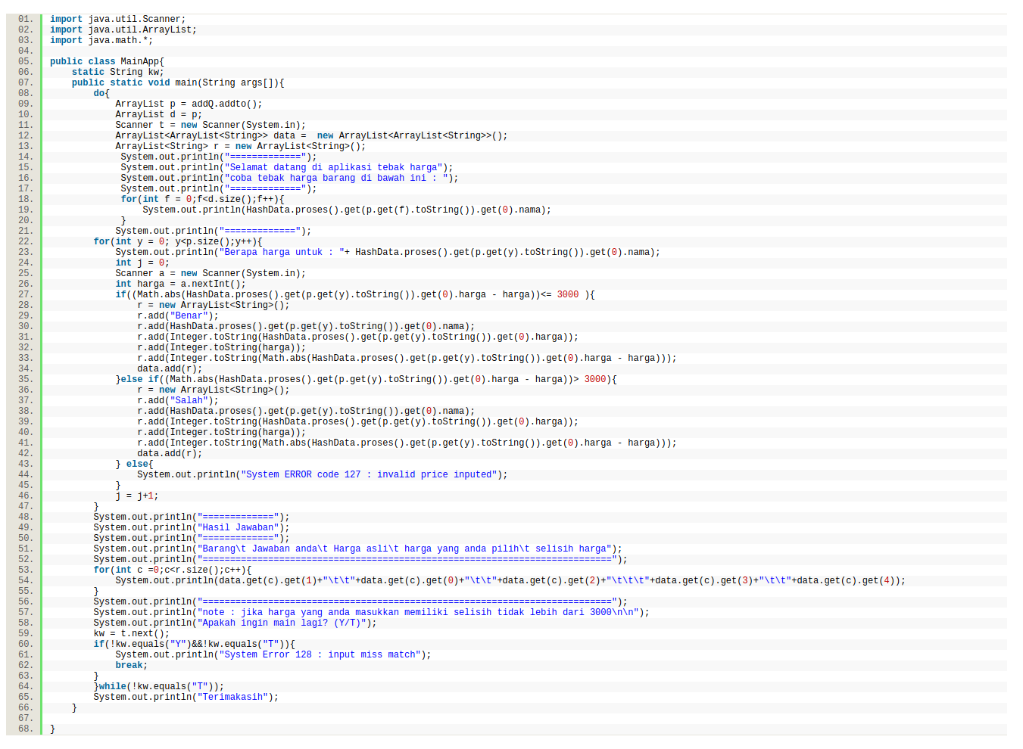MainApp.java

Output :

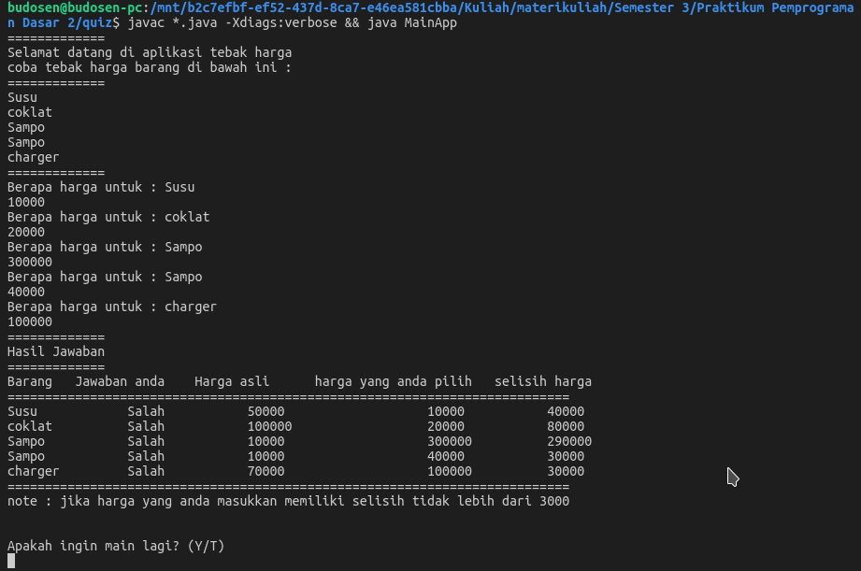

github : https://github.com/bijancot/materikuliah/tree/master/Semester%203/Praktikum%20Pemprograman%20Dasar%202/quiz